1 ) URL : <http://localhost:9090/screens>

Request Body : { "name":"inox",

"seatInfo": { "A": { "numberOfSeats": 10, "aisleSeats": [0, 5 ,6, 9] },

"B": { "numberOfSeats": 15, "aisleSeats": [0, 5 ,6, 9] },

"D": { "numberOfSeats": 20, "aisleSeats": [0, 5 ,6, 9] }

}

}

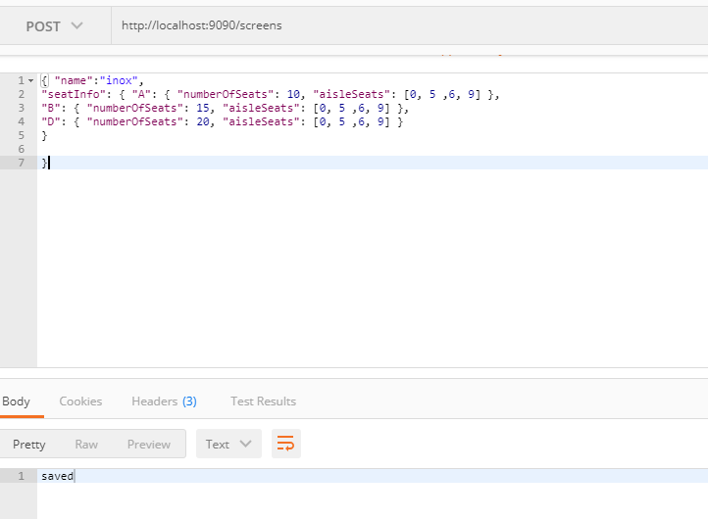

2) url : <http://localhost:9090/screens/inox/reserve>

Request body : { "seats": { "B": [0], "D": [0,1,2,3,4,5] } }

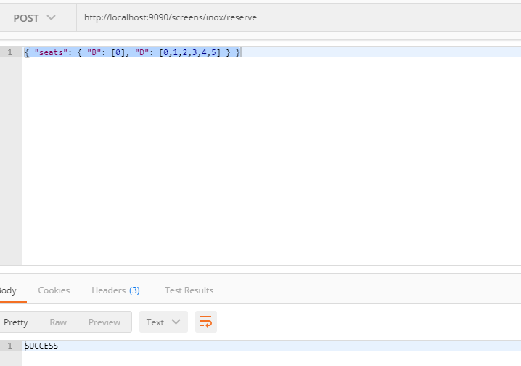

3 )

url : <http://localhost:9090/screens/inox/seats?status=no>

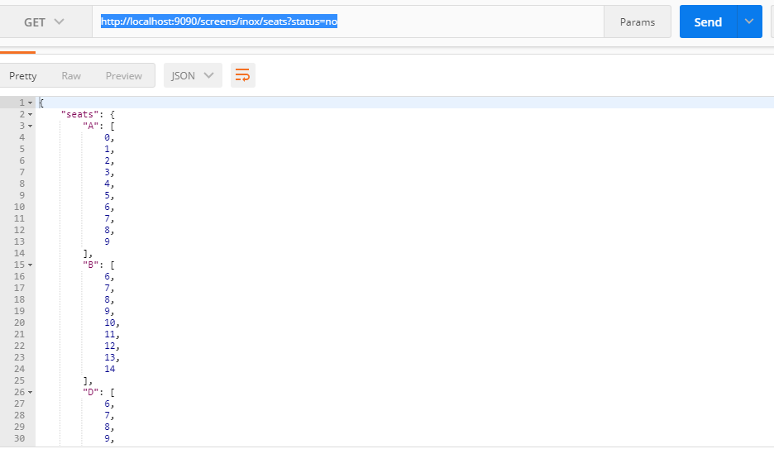

4) Get screen details

url : <http://localhost:9090/screens/inox>

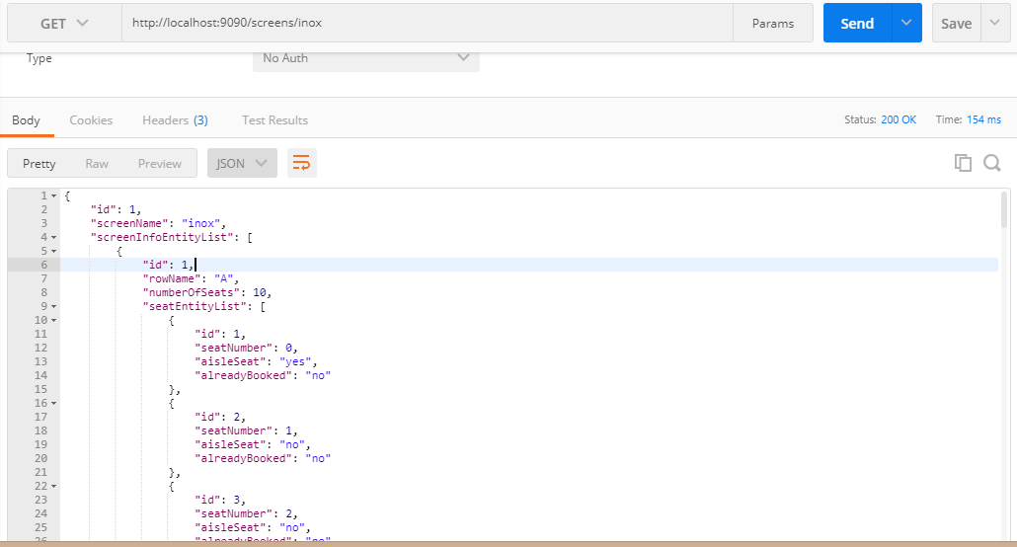

response : {

"id": 1,

"screenName": "inox",

"screenInfoEntityList": [

{

"id": 1,

"rowName": "A",

"numberOfSeats": 10,

"seatEntityList": [

{

"id": 1,

"seatNumber": 0,

"aisleSeat": "yes",

"alreadyBooked": "no"

},

{

"id": 2,

"seatNumber": 1,

"aisleSeat": "no",

"alreadyBooked": "no"

},

{

"id": 3,

"seatNumber": 2,

"aisleSeat": "no",

"alreadyBooked": "no"

},

{

"id": 4,

"seatNumber": 3,

"aisleSeat": "no",

"alreadyBooked": "no"

},

{

"id": 5,

"seatNumber": 4,

"aisleSeat": "no",

"alreadyBooked": "no"

},

{

"id": 6,

"seatNumber": 5,

"aisleSeat": "yes",

"alreadyBooked": "no"

},

{

"id": 7,

"seatNumber": 6,

"aisleSeat": "yes",

"alreadyBooked": "no"

},

{

"id": 8,

"seatNumber": 7,

"aisleSeat": "no",

"alreadyBooked": "no"

},

{

"id": 9,

"seatNumber": 8,

"aisleSeat": "no",

"alreadyBooked": "no"

},

{

"id": 10,

"seatNumber": 9,

"aisleSeat": "yes",

"alreadyBooked": "no"

}

]

},

{

"id": 2,

"rowName": "B",

"numberOfSeats": 15,

"seatEntityList": [

{

"id": 11,

"seatNumber": 0,

"aisleSeat": "yes",

"alreadyBooked": "no"

},

{

"id": 12,

"seatNumber": 1,

"aisleSeat": "no",

"alreadyBooked": "no"

},

{

"id": 13,

"seatNumber": 2,

"aisleSeat": "no",

"alreadyBooked": "no"

},

{

"id": 14,

"seatNumber": 3,

"aisleSeat": "no",

"alreadyBooked": "no"

},

{

"id": 15,

"seatNumber": 4,

"aisleSeat": "no",

"alreadyBooked": "no"

},

{

"id": 16,

"seatNumber": 5,

"aisleSeat": "yes",

"alreadyBooked": "no"

},

{

"id": 17,

"seatNumber": 6,

"aisleSeat": "yes",

"alreadyBooked": "no"

},

{

"id": 18,

"seatNumber": 7,

"aisleSeat": "no",

"alreadyBooked": "no"

},

{

"id": 19,

"seatNumber": 8,

"aisleSeat": "no",

"alreadyBooked": "no"

},

{

"id": 20,

"seatNumber": 9,

"aisleSeat": "yes",

"alreadyBooked": "no"

},

{

"id": 21,

"seatNumber": 10,

"aisleSeat": "no",

"alreadyBooked": "no"

},

{

"id": 22,

"seatNumber": 11,

"aisleSeat": "no",

"alreadyBooked": "no"

},

{

"id": 23,

"seatNumber": 12,

"aisleSeat": "no",

"alreadyBooked": "no"

},

{

"id": 24,

"seatNumber": 13,

"aisleSeat": "no",

"alreadyBooked": "no"

},

{

"id": 25,

"seatNumber": 14,

"aisleSeat": "no",

"alreadyBooked": "no"

}

]

},

{

"id": 3,

"rowName": "D",

"numberOfSeats": 20,

"seatEntityList": [

{

"id": 26,

"seatNumber": 0,

"aisleSeat": "yes",

"alreadyBooked": "no"

},

{

"id": 27,

"seatNumber": 1,

"aisleSeat": "no",

"alreadyBooked": "no"

},

{

"id": 28,

"seatNumber": 2,

"aisleSeat": "no",

"alreadyBooked": "no"

},

{

"id": 29,

"seatNumber": 3,

"aisleSeat": "no",

"alreadyBooked": "no"

},

{

"id": 30,

"seatNumber": 4,

"aisleSeat": "no",

"alreadyBooked": "no"

},

{

"id": 31,

"seatNumber": 5,

"aisleSeat": "yes",

"alreadyBooked": "no"

},

{

"id": 32,

"seatNumber": 6,

"aisleSeat": "yes",

"alreadyBooked": "no"

},

{

"id": 33,

"seatNumber": 7,

"aisleSeat": "no",

"alreadyBooked": "no"

},

{

"id": 34,

"seatNumber": 8,

"aisleSeat": "no",

"alreadyBooked": "no"

},

{

"id": 35,

"seatNumber": 9,

"aisleSeat": "yes",

"alreadyBooked": "no"

},

{

"id": 36,

"seatNumber": 10,

"aisleSeat": "no",

"alreadyBooked": "no"

},

{

"id": 37,

"seatNumber": 11,

"aisleSeat": "no",

"alreadyBooked": "no"

},

{

"id": 38,

"seatNumber": 12,

"aisleSeat": "no",

"alreadyBooked": "no"

},

{

"id": 39,

"seatNumber": 13,

"aisleSeat": "no",

"alreadyBooked": "no"

},

{

"id": 40,

"seatNumber": 14,

"aisleSeat": "no",

"alreadyBooked": "no"

},

{

"id": 41,

"seatNumber": 15,

"aisleSeat": "no",

"alreadyBooked": "no"

},

{

"id": 42,

"seatNumber": 16,

"aisleSeat": "no",

"alreadyBooked": "no"

},

{

"id": 43,

"seatNumber": 17,

"aisleSeat": "no",

"alreadyBooked": "no"

},

{

"id": 44,

"seatNumber": 18,

"aisleSeat": "no",

"alreadyBooked": "no"

},

{

"id": 45,

"seatNumber": 19,

"aisleSeat": "no",

"alreadyBooked": "no"

}

]

}

]

}